

APP 141 Test Strategy Work Product
Call Center Application Desktop
Author: IBM Global Business Services

December 6, 2006
Document History
Document Location
This is a snapshot of an on-line document. Paper copies are valid only on the day they are printed. Refer to the author if you are in any doubt about the currency of this document.
The source of the document can be found in Rational Portfolio Manager.
Revision History
Date of this revision: 01/10/2007 | Saved by: IBM_USER

Revision Number | Revision Date | Author | Summary of Changes | Changes marked
0.01 | 12/2/06 | Willie H. Mims | Initial Draft | N
1.0 | 12/7/06 | Chris Garrett | Migrated to template | N

Approvals
This document requires following approvals. Signed approval forms are filed in the Quality section of the PCB.
Name | email | Title / Role
(name) | (email) | (title or role)
Distribution
This document has been distributed to
Name | email | Title / Role

Table of Contents
1. Introduction 6
1.1 Description 6
1.2 Purpose 7
1.3 Audience 7
2. Background 8
2.1 Project Overview 8
2.2 Application Architecture Overview 8
3. Lifecycle Testing Methodology Overview 10
3.1 Lifecycle Testing Processes 10
3.2 Phases of Testing 11
3.2.1 Static Testing 12
3.2.2 Development Testing 12
3.2.3 Integration/Functional Testing 12
3.2.4 System Testing/System Integration Testing 13
3.2.5 User Acceptance Testing (UAT) 13
3.2.6 Regression Testing Approach 13
3.3 Test Automation 14
4. CCA Test Methods and Techniques Overview 15
4.1 CCA Testing Objectives 15
4.2 Features and Functions to be Tested 15
4.3 Features and Functions not to be Tested 16
4.4 CCA Test Approach 16
4.5 Conceptual Illustration of CCA Testing Approach 17
4.6 Key CCA Testing Methods and Techniques 17
4.7 Test Entrance and Exit Criteria 21
5. Processes and Procedures 23
5.1 Test Status Reporting 23
5.2 Test Defect Reporting 23
5.3 Test Completion Report 23
5.4 Test Requirements 23
5.5 Test Assumptions 23
5.6 Test Constraints 24
5.7 Risks 24
5.8 External Dependencies 24
6. Key Input Documents 26
7. Resources 27
7.1 Roles and Resources 27
7.2 Environment 28
7.3 Tools 28
7.4 Defect Management 29
8. Timeline 31
8.1 Test Milestones 31
8.2 Conceptual Schedule 31
9. Deliverables 32
9.1 Test Deliverables 32
9.2 Metrics 32
10. Appendix 33
10.1 Appendix B: Test Entrance Criteria 33
10.2 Appendix C: Test Exit Criteria 36
10.3 Appendix E: Test Plan Glossary 37
Table of Figures

Figure 1: Architectural Overview – CIGNA CCA Application 9
Figure 2: Lifecycle Testing Overview 10
Figure 3: Testing Process 11
Figure 4: Features and Functions to be Tested 15
Figure 5: Features and Functions not to be Tested 16
Figure 6: CCA Test Approach Highlights 16
Figure 7: Conceptual Illustration of CCA Testing Approach 17
Figure 8: Key Strategies 17
Figure 9: Test Entrance/Exit Criteria 21
Figure 10: Test Dependencies 24
Figure 11: Key Input Documents – Deliverables 26
Figure 12: Roles and Resources 27
Figure 13: Environment 28
Figure 14: Testing Tools 29
Figure 15: Defect Severity Codes 29
Figure 16: Conceptual Schedule 31
Figure 17: Matrix of Test Deliverables 32
Figure 18: Metrics 32
Figure 19: Test Entrance Criteria 33
Figure 20: Test Exit Criteria 36
Figure 21: Test Plan Glossary 37

Introduction

Description
Test Strategy is a high-level description of major system-wide activities that collectively achieve the overall desired result, as expressed by the testing objectives. It outlines the approach to be used to ensure that the critical attributes of the system are tested adequately. It starts with a high-level description of the “what” needs to be tested. The Test Strategy includes elements and information that are generic in nature. At this stage these could be generic to an industry, an application or a group of applications. No attempt is made to get specific at this time. The test strategy should be developed early in the project lifecycle during start up time or, preferably, during the Statement of Work or proposal time. It will quite often only describe a generic approach and steps to be taken to ensure the quality of the product.
All strategy statements are expressed in high-level terms of physical components and activities, resources (people and machines), and types and levels of testing; i.e., the stuff of which action plans are made at lower levels. In most situations, these are merely definitions of terms and terminology, used to establish a common understanding and lay the foundation to initiate the next step, which is test planning.
Test strategy document includes, at a high level:
- Testing objectives: Set the direction for testing.
- Risk assessment: Initial assessment of business and technical risks from Project Management or from Solution Assurance Reviews.
- Test Focus Areas: Critical attributes of the system to be tested.
- Levels of test: Testing levels based on known standards within the client organization or IBM, or a combined set of both, that reflect levels needed to meet quality criteria defined in the Statement of Work.
- Types of test: Testing types to consider, relating to business functions (Functional Types) or to structural functions (Structural Types).
- Organizational responsibility: Based on project deliverables.
- Entry/Exit Criteria: Defined for different levels and for their importance to project success.
- Tools: Any technology or tools strategy, at the client organization or IBM, relevant to the project.
- Metrics: Any organization, business unit, competency metrics program or measurements strategy relevant to project quality criteria.
It is equally important to note that planning details are NOT included here.

Purpose
The purpose of the Test Strategy work product is to:
- Define how the appropriate testing principles and practices will be applied in order to mitigate the project risks, manage the testing risks, and identify any exposures.
- Provide a common approach and a common terminology to use for testing across multiple organizational structures and business units.
- Give a general direction for where testing is headed.
- Emphasize the importance of a cost-effective, team approach to testing.
- Describe the complexity of full lifecycle testing.
- As a communication vehicle to identify any testing issue early rather than late.

Audience
The following have been identified as the audience for this document.
• CCA Desktop Business Units / Stakeholders
• CCA Desktop UAT Stakeholders
• IT Test Team
• Project Managers
• Business Analysts / SMEs
• Senior Leadership
• Developers
• Data Architects
• System Architects

Background

Project Overview
The CRM Capabilities Initiative evolves from CIGNA's Strategy to achieve the following business imperatives:
- Integrated Execution - Seamless marketing, Sales and Service processes across the Enterprise
- Outreach and Dialogue - Pro-active and intelligent communication to build advocacy and promote CIGNA offerings
- Stakeholder Insight - Management of stakeholder information as a strategic asset.
Call Center Application (CCA) is one of several delivery efforts within CIGNA’s CRM Capabilities Program. The project will deliver a desktop application for CIGNA Customer Service Agents (CSAs) to be deployed across multiple lines of business (Medical, Pharmacy, Dental, Group Insurance, Intracorp, and Behavioral Health) to track constituent interactions, manage follow-up on constituent issues, and access back-end source applications and data needed to resolve issues and respond to inquiries.
CCA will replace CIGNA’s existing Siebel iCare CRM solution, currently deployed to the Medical and Pharmacy lines of business, and its existing CSS CRM application, used in the Dental and Pharmacy lines of business.

Application Architecture Overview
The CCA Desktop solution is a Websphere Portal/Chordiant CSA desktop application to support CRM requirements across CIGNA’s lines of business. The solution will include:
- A role-based portal that provides a unified CSA desktop;
- A new Enterprise Services Bus (ESB) that will be integrated with CIGNA’s planned Enterprise Services Bus to support the deployment of SOA services and enable access to required data across multiple legacy applications;
- Contextual knowledge integrated with CCA;
- Automated dialing capability integrated within CCA.

The CCA Desktop architecture is a modular design that incorporates WebSphere Portal, Choridant Business Services, Chordiant Databases, CTI Chordiant Framework, WebSphere App Server, Tivoli Access Manager and DB/2 into a powerful solution when coupled with custom coding and SOA principles.
The Enterprise View of the Architecture Overview identifies the high level business components that need to be developed to support CCA. Many of these components are part of the out-of-the-box WebSphere Portal implementation, standard Chordiant Foundation Server layer, and related external components (such as Tivoli Access Manager and DB2), while others will be developed for the portal platform (commonly referred to as custom codes)..
The Architectural Overview below indicates an End-to-End view of the Solution Architecture.

Figure 1: Architectural Overview – CIGNA CCA Application
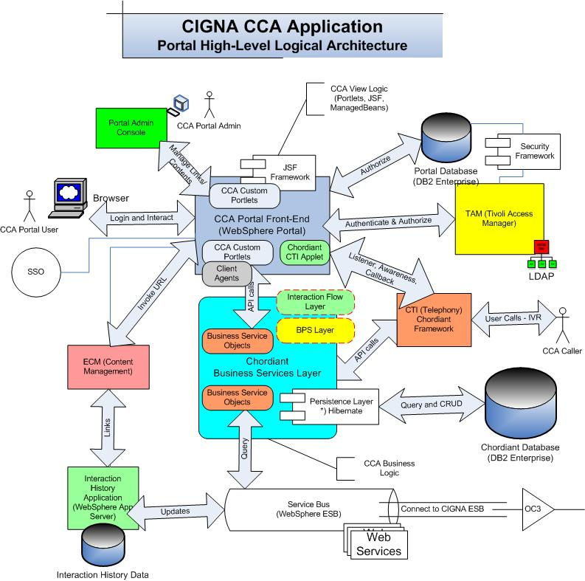

Lifecycle Testing Methodology Overview
The CCA Desktop testing effort will deploy structured testing methods consistent with the Full Lifecycle Testing Methodology. Under IBM’s Global Services Methodology, a systematic deployment of proven static and dynamic testing activities are applied to uncover application defects and drive high Quality into the software solutions.
The figure below highlights the Solution Development Stages, Key Levels and Types of Testing performed during the Solution Development Stages.
Figure 2: Lifecycle Testing Overview
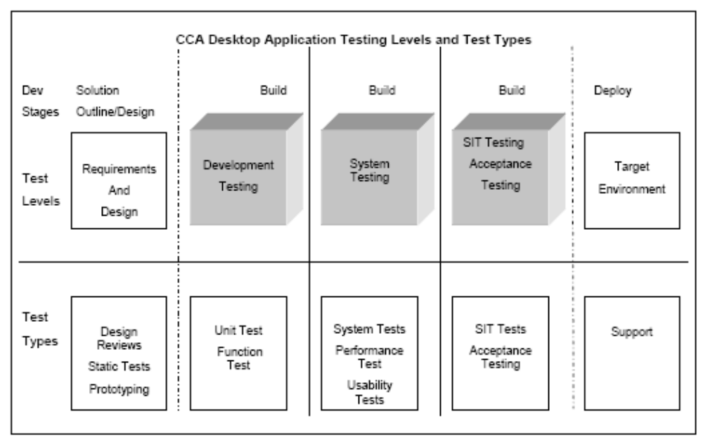

Lifecycle Testing Processes
The IBM Global Services Method (GSM) supports the development of the CCA Desktop solution. The Test Process Model is defined in GSM and it is the guideline for structuring CCA Desktop Testing.
The Test Model consists of the following sub-processes:
- Testing Project Start-up – Initialize the Testing Project - Start-up covers the customary project management initialization activities.
- Test Assessment and Planning – Plan and Prepare for Testing - Sets the strategy for testing, the scope and objectives including plans for Static Testing. The test planning activities start in the requirements definition phase of the solution development lifecycle and continue through to end of the solution design phase when they get completed and signed off.
- Test Design – Design and Prepare for Testing - Includes the creation of test specifications for each of the detailed levels of testing. It also includes the design of the test environments including testware configuration. It can be associated with the high level and detailed design phases of the development lifecycle
- Test Execution and Reporting – Execute and Report on Testing - Includes executing the different levels of test and reporting. When the tests are executed, results are captured, variances are analyzed and action taken. Periodic management meetings report the progress and status of testing.
- Test Implementation and Close – Archive Assets and Close - Test assets that have been captured are catalogued for re-use. Test plans are updated for future use. Testware is packaged for handover to maintenance. Final test measurements are produced, causal analysis is performed and test process improvements are identified. The project is closed with the completion of customer sign off and acceptance.
The CCA Desktop Test Process adopted from GSM is an iterative process. These steps are followed at the overall project level and repeated for each level of testing required in the development lifecycle. This process is shown in the Test Process Overview diagram below.
Figure 3: Testing Process
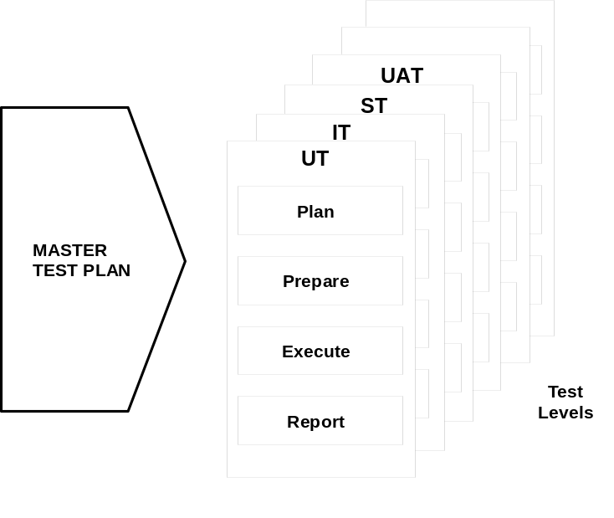

Phases of Testing

The following test levels and testing descriptions have been identified for CCA Desktop Testing.

Static Testing
Static testing involves testing of the development work products before any code is developed. Commonly used static testing techniques are prototyping, reviews, inspections, and walkthroughs. This testing is performed at the module level.
- Performed by the Development Team, Test Team with other stakeholders
- Environment Infrastructure – TBD
- Acceptance Criteria – Inspections, Reviews and Walkthroughs are performed on key development work products namely Requirements, Designs, Code, Test Plans and Test cases

Development Testing
Development Testing ensures the accuracy and integrity of the logic coded within a module. Typically, this testing is called Unit Test. Unit Level Testing is the initial testing of new and changed code in a module. It verifies the program specifications to the internal design of the program or module and validates the logic. All logic paths and conditions are tested to ensure accuracy and correctness. This testing is performed at the module level and will be deployed for CCA.
- Performed by the Developer
- Environment Infrastructure – The Development Systems will be used for CCA
- Acceptance Criteria – No errors or warning messages received on the code. Logic is complete and accurate

Integration/Functional Testing
Integration Testing is performed to verify the interfaces and exchanges of data. Integration Level Tests verify proper execution of application components and do not require that the application under test interface with other applications. Modules comprising a specific function are built and tested together for purposes of testing functionality, interfaces and logic accuracy. Integration Testing is planned for CCA and will be performed in a controlled environment within the project.
- Performed by the Dev Team
- Environment Infrastructure – The DEV Environment will be used for CCA.
- Acceptance Criteria – Each function performs as expected and created data structures are complete and accurate. Defined Test Cases execute successfully

System Testing/System Integration Testing
CCA System Testing and System Integration Testing ensure the integrity of the entire release. The solution will be treated as a black box with inputs and outputs evaluated for accuracy. System Level Tests verify proper execution of the entire application components including interfaces to other applications.
- Performed by CCA Test Team
- Environment Infrastructure – The SIT Environment will be used for CCA
- Acceptance Criteria – Defined Test cases execute successfully

User Acceptance Testing (UAT)
User Acceptance Testing validates the operational and functional capabilities to satisfy the customer’s business processes. UAT verifies that the solution meets user requirements as specified.
Concerning the CCA Desktop Strategy and Plan for User Acceptance Testing, an additional document will be created to specify goals, definitions and activities for UAT. The Acceptance Test Plan document, when generated by CIGNA, will exist as a separate document.
Approval of the UAT Testing Strategy will occur separately from this CCA Testing Strategy document.
- Performed by a separate Business Analyst Team. This testing is the responsibility of CIGNA and IBM will assist the UAT effort as required. Test environment assistance and UAT environment readiness checks will be performed by IBM
- Environment Infrastructure – CCA Desktop UAT Environment
- Acceptance Criteria – Additional planning must occur on this area of testing

Regression Testing Approach
Regression Testing verifies that no unwanted changes were introduced to one part of the solution as a result of making changes to another part of the system. Regression testing will be performed at every level of testing; if any changes are made to the code, it will be unit tested before the fix is implemented in other environments.
Test execution metrics will influence the content of a Regression Test Cycle:
- Detected Errors within a Feature – the number of errors detected within a feature will indicate a need for on-going Regression Testing. If the error counts are high, test cases associated with this feature will be assigned to the Regression Suite. A suite, or grouping of test cases, will be executed during the regression test window or cycle
- Testcase Failures on High Value Features/Functionality – Each testcase or scenario will have an assigned priority based on value. High value functions within the application will have high priorities assigned to the corresponding test cases. In iterative testing, if these testcases routinely fail, those failing test cases will be assigned to the Regression Suite
Criteria:
- Performed by a test team
- Environment infrastructure – Testing will be done in all levels using the same environment
- Acceptance Criteria – Application performs the same after defect repair

Test Automation
Some number of testcases will be automated for the following purposes:
- Smoke Testing - A Smoke Test reflects a narrow subset of cross-application testcases that are executed as a rapid readout of end-to-end integration or solution completeness. Automated testcases will be included for Smoke Testing.
- Configuration Validation – The Chordiant Application Package may become a target for automation. Automation may be useful in validating correct set-up of the operational configuration values. The assessment to automate will be determined based on the number of configuration defects between the DEV and SIT/UAT Environments
- On-going Regression Testing – The initial execution of a test will occur under manual control. If the test is suitable for Regression, if will become a candidate for automation. At this time, a committed number of automated test scripts have not yet been established.

CCA Test Methods and Techniques Overview

CCA Testing Objectives
CCA Desktop Testing is designed to achieve the following:
- Ensure that each function and feature of the CCA Desktop solution functions properly and each module works when integrated with the others.
- Ensure that all requirements are verified by employing a representative subset of data.
- Validate implementation of Usability and Performance Features

Features and Functions to be Tested
The CCA Desktop application inherits testing complexity driven by rich end-user functionality, new SOA Technology, integrations with Chordiant/WedSphere Services, customizations and external application interfaces.
The table below presents an overview of the high-level components to be tested. Actual test conditions will be derived from the development artifacts namely requirements documentation, design documentation, developer discussions/reviews and SME discussions/reviews.
Figure 4: Features and Functions to be Tested
Validations | Descriptions
Use Cases | - See CCA Solution Outline – Use Case Survey
Requirements Report | - See CCA Solution Outline – Requirements Report
Incremental Requirements | - See CCA Solution Outline – Incremental Requirements List
Non-Function Requirements | - See CCA Solution Outline – Non-Functional Requirements
Usability Requirements | - See CCA Solution Outline – Usability Requirements
External Systems | - External Security Manager  - CTI Telephony  - Interaction History (IH)  - Enterprise Content Management (ECM)
SOA Frameworks | - CCA user Interface Layer  - CCA Chordiant SOA Orchestration Layer  - ESB layer

Features and Functions not to be Tested
The following is a list of features that will not be tested as part of CCA Desktop solution.
Figure 5: Features and Functions not to be Tested
Feature/Function | Description
Full Scale Databases | CCA Desktop Testing will utilize a subset of data scaled based on test environment capacity.

CCA Test Approach
An iterative development approach will be used to deliver each release of CCA. The first iteration will address high priority functionality that presents the highest architectural risk and/or represents “foundation” elements for the application.
This approach will require testing to address the following:
Figure 6: CCA Test Approach Highlights
Code Drop | Description | Highlights of Testing Approach
Proof of Concept | The Proof of Concept (POC) will produce a code drop demonstrating critical component of the Architecture. These critical components may include logical elements as follows:  - CCA Portal Front-End  - Chordiant Orchestration Layer  - Business Process Server  - Chordiant Foundation Services  - Persistence  - Decision Engine  - Integration points to External Systems | - DEV Environment is used for Testing  - Code Drop contains a sub-set of critical functionality  - Coding – Release Package creation is optional  - Dev Testing Performed – Unit / Function/ System  - System Testing  - Performance Test Optional  - Usability Test Optional  - SIT Testing – sub-set can be performed – not all external interfaces are tested  - UAT – Not Required
Release Iteration | Release Iteration – The Release Iteration will contain the functionality of an approved set of requirements and Use Cases. This Iteration is created for implementation into production and the full scope of required testing must be accomplished | - SIT Test Environment is used for Testing  - Code Drop contains a full drop of critical functionality. Requirements covered must be declared for testing planning and coverage.

Conceptual Illustration of CCA Testing Approach
Figure 7: Conceptual Illustration of CCA Testing Approach
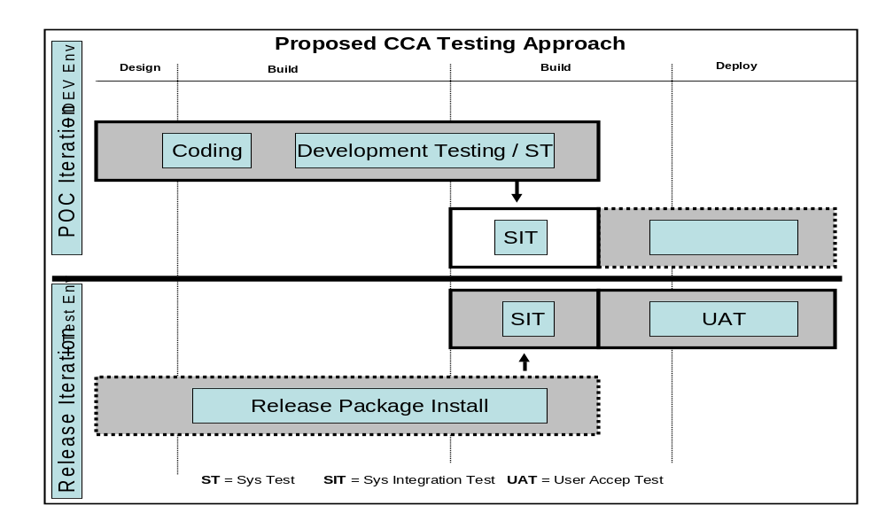

Key CCA Testing Methods and Techniques
Figure 8: Key Strategies
Key Strategy | Focus | Methodology
Static  Testing | Reviews | Objective:  - Remove defects using reviews as a method to derive errors before test execution  Techniques:  - Requirements and Design Reviews  - Test Case Reviews
Test Case Design and Development | Testing Artifact | Objective:  - Establish testing artifacts that address test conditions covered during Test Execution  - Define methods used to ensure coverage of Functional and Non-functional requirements  Techniques:  - Testcases are designed by the CCA Test Team and stored in Rational TestManager  - Requirements Documents, Design Documents, Use Cases and Prototyping Output will serve as input to Testcase Design  - A requirement Tracability Matrix (RTM) will be established to link Testcases to requirements
Dynamic Testing | Unit Testing | Objective:  - Test the function of a program or unit of code such as a program or module. During CCA Unit Test, each newly created or modified module will undergo Unit Level Testing  - Remove defects at the module level  Techniques:  - Test code, structure, branching and processing accuracy  - CCA Unit Level testing may involve usage of Unit Test Automation Tools to ensure effective testing of the module.  - Tools used for Unit Testing will be specified in the Detailed Test Plan  - Unit Test results will be captured and reconciled to modules that were created or modified
 | Integration/  Functional Testing | Objective:  - Technically verify proper interfacing between modules and within sub-systems  Techniques:  - Group modules into functional categories  - Execute tests by functions  - Negative path test conditions and testcases
 | System Testing | Objective:  - Verify that the systems perform both functionally and operationally as specified  - Test scenarios representing end-to-end business processes  Techniques:  - Test cases combined in “threads” to verify detailed processing and the joint execution of related functions  - Test cycles executing selected test cases to simulate time-related business activities  - End-to-end test scenarios to verify key functions required supporting long-term business operations
 | System Integration  Testing | Objective:  - Verify that the application interfaces both functionally and operationally as specified in requirements  - Execute Test scenarios representing each external interface  Techniques:  - Test cases combined in “threads” to verify detailed processing and the joint execution of related functions  - Test cycles executing selected test cases to simulate time-related business activities  - End-to-end test scenarios to verify key functions required supporting long-term business operations
 | Error  Handling | Objective:  - Verify errors are following a standard error-handling procedure at CIGNA  Techniques:  - Error-handling standards are validated by employing erroneous data and simulated system conditions and/or business scenarios
 | Security | Objective:  - Non-Functional requirements for Security must be fully specified in the requirement documentation  - Validate Security requirements for a CCA Desktop user  Techniques:  - Create security tests for various roles  - Validate security error-handling procedures
 | Performance | Objective:  - Ensure Performance objectives are achieved based on non-functional requirements.  Techniques:  - Additional planning will occur on this topic to refine methods and tool utilization  - Performance Testing is required to support CCA Desktop
 | Usability | Objective:  - Ensure usability of the system is achieved consistent with User Approved UI Designs.  Techniques:  - User Walkthrough sessions will be scheduled to confirm usability.  - Usability Assessment for CCA – To Be Defined
 | Installation | Objective:  - Verify/validate installation requirements if any  Techniques:  - Execute tests to ensure installation is complete. Some number of test cases will be written for this area  - Will be a repetitive process used to install driver code  - System Level Software (e.g. Websphere) will not require an Installation Test
 | UAT | Objective:  - Ensure system’s functions are consistent with approved Business Rules, Use Cases and Requirements  Techniques:  - Define and execute Business End-to-End Scenarios to confirm functionality  - This testing level will require additional definition by the CIGNA UAT Team.
Regression | Stability | Objective:  - Ensure that defects have not been introduced as a result of changes between two builds, versions or releases of the systems  Techniques:  - Once test cases for above test types are executed without any script failures or new defects being reported, they are included in the regression suite  - The regression suite is then executed against any new build, versions or release
Automation | Productivity / Stability | Objective:  - Test cases are designed and automated using an approved automated testing tool  Techniques:  - A level of Test Automation will be applied for CCA Desktop.  - During SIT – The Rational Test Tools will be available
Test Data | SIT Data | Objective:  - Ensure data is adequate to perform required tests  Techniques:  - Fully scaled production sized data volumes are not planned for CCA Desktop Testing  - CIGNA will provide testing data for SIT and User Acceptance Testing.

Test Entrance and Exit Criteria
The concept of establishing pre-requisites (entrance criteria) and post conditions (exit criteria) for an activity to be undertaken is necessary for managing the testing process.
Entrance criteria are those factors that must be present, at a minimum, to be able to start an activity. Exit criteria are those factors that must be present to declare an activity completed.
Test execution can begin once test planning and test environment engineering is complete and all criterion on the Test Entrance and Test Exit Criteria checklist are fulfilled (refer to Appendix B: Test Entrance Criteria and Appendix C: Test Exit Criteria for more details).
Figure 9: Test Entrance/Exit Criteria
Test Stage | Test Stage Entry Criteria | Test Stage Exit Criteria
Development - Unit | - Design and Coding Complete  - Test Cases Complete  - Test Plan complete  - Test Environment Established | - Unit Testing Complete  - No open High severity defects  - All Unit test scripts and test results successful  - Defect Support / Fix Team Contact  - Agreement on Defect/Fix Delivery Process and Schedule
System and Integration | - Development testing Complete  - Test Environment Established  - Test Scripts  - Defect Support Team  - Configuration management and Release Management in place  - Problem Management Process | - No open high severity defects  - All test scripts successful
Acceptance Testing | - Section requires additional input from MBNA team  - System and Integration Testing Complete  - Test Environment Established  - Test Scripts  - Defect Support / Fix Team  - Problem Management Process | - No open high severity defects  - All test scripts successful

Processes and Procedures

Test Status Reporting
The status and progress of CCA test activities are evaluated by conducting formal and informal reviews, by reporting progress and status against major and intermediate milestones, and through a detailed project plan.

Test Defect Reporting
Rational ClearQuest will be used to support the collection and tracking of defects.

Test Completion Report
The goal of this final report is to summarize the test activities for the CCA Testing project and to provide the test team with an opportunity to evaluate the test process as a whole. A final draft of the Test Completion Report will be ready after Rollout to Pre-Production. It will be delivered to available approximately 10 business days after go-live.

Test Requirements
RequisitePro is the requirements management tool for the CCA Desktop project. RequisitePro provides the capability to maintain and document requirements while leveraging analytical capabilities such as requirements analysis, coverage and change impact.

Test Assumptions
This section identifies assumptions made when formulating this Testing Strategy:
- Adequate and sufficient testing resources are available when needed.
- Baselined and Final Requirements are available before Test Planning begins. Changes to requirements will occur under Change Management.
- SME’s are identified in support of the testing efforts before Test Planning begins.
- Unit Testing and peer reviews are conducted, results documented and any Unit Test defects resolved prior to System Test.
- The SIT test environment is ready and functioning before (+2 weeks) SIT is scheduled to begin
- Developers will not make code changes to objects within the SIT Libraries. Introduction of fixes must occur through Configuration Management
- Code is locked-down and turned over to testing before System Test.

Test Constraints
This section identifies obstacles beyond the control of the testing team that may limit the testing process.
- Completeness and Accuracy of Technical Documentation for Test Design and Test Case preparation.
- Completeness and Accuracy of Test Environment
- Unavailability or late delivery of required hardware, software, data or tools.

Risks
The following have been identified to date. Additional risks may surface as testing progress.
- Test Preparation risks stemming from unfinished levels of detail regarding Business Rules, UI Designs, Roles Based Security Requirements and Use Cases.
- Architectural complexity of CCA Desktop

External Dependencies
CCA Desktop Testing has surfaced the following Table of Dependencies:

Figure 10: Test Dependencies
Category | Description | Ownership
Test Environments | Test Environments, including hardware and software maintenance, are provided by Shared Services Team | Shared Services
Test Data | Test Data is created and provided to CCA Testing by CIGNA.  - Owner ship of test data not yet defined  - Timelines for data delivery not yet established | CIGNA - TBD
Test Tool Installation | Server installation of Testing Tools resides outside of the test team. Currently, the Rational Tool Set namely ClearQuest, RequisitePro and TestManager is needed in support of CCA testing. | Shared Services
Configuration Management and Driver Builds | Driver Builds are provided by a separate team from Testing. | Shared Services

Key Input Documents
This section defines the documentation baseline of factual content that feeds the Test Strategy Document.
The table below identifies the documentation that is available within the project and the artifacts, documents or models that are referenced for this strategy.
The document archive resides in RPM.
Figure 11: Key Input Documents – Deliverables
Document (and version) | Author or Resource | Target | Archive
Solution Outline – Requirements Report |  |  | RPM
Business Rules Catalog |  |  | RPM
System Context Work Product |  |  | RPM
Incremental Requirement List |  |  | RPM
Use Case Survey Work Product |  |  | RPM
CCA Project Charter |  |  | RPM
Usability Requirements Work Product |  |  | RPM

Resources

Roles and Resources
Figure 12: Roles and Resources
Role Name | Responsibility
CIGNA Test Liaison  CRM Capabilities QA and Testing  - Mr. Gerald MacDonald | - CIGNA Liaison contact for all program wide testing activities in support of CCA Application Testing  - Issue Management focal point  - Key Interface to the CIGNA Testing Community
CIGNA Business Unit Testing Contact | - UAT Test Preparation and Execution
IBM Test Manager  CRM Capabilities QA and Testing  - Mr. Willie Mims | - Test Team Leadership and Project Management  - Provides central coordination for all testing activities in support of the CCA Application Testing.  - CRM Capabilities Test Strategy Owner  - Testing Issue, Risk and Dependency Management Focal Point  - Test Reporting, Project Planning and Test Execution Leader  - Technical leadership of CCA Test Personnel
CCA Lead Tester  - TBD | - Primary contact point for testing status and strategy for CCA  - Generates and administers the Test Plans and Strategies specifically Unit, Integration and System Test Plans  - Provide Test Methodology expertise consistent with IBM Global Services Method  - Perform selection and tailoring of application testing tools platforms  - Technical leadership of CCA Test Personnel
Testers / Analysts / Engineers  - TBD | - Facilitate the CCA testing processes  - Create Testing Artifacts including Test Designs, Specifications and Test Results  - Applies methodologies to achieve Quality and Schedule Objectives  - Resolve issues and manage risks  - Consolidate the test status on specific functionality and make technical recommendations on test methods and approaches  - Leverage Test Automation Tools to improve efficiency and productivity within the testing process.

Environment
This section lists the environment for each test stage.
Figure 13: Environment
Test Stage | Environment Solution | Environment Location
Development | - A dedicated and exclusive environment will be available for CCA Development and Testing  - Server Name - TBD  - Environment Location – Dallas, TX | CRM Capabilities Shared Services Team is contact for Environment Set-up
System and Integration  Testing – SIT | - A dedicated and exclusive environment will be available for CCA SIT and UAT Testing  - Server Name - TBD  - Environment Location – Dallas, TX | CRM Capabilities Shared Services Team is contact for Environment Set-up
Acceptance  Testing - UAT | - A dedicated and exclusive environment will be available for CCA SIT and UAT Testing  - Environment sharing between SIT and  UAT to be determined  - Server Name - TBD  - Environment Location – Dallas, TX | CRM Capabilities Shared Services Team is contact for Environment Set-up

Tools
This section identifies the tools needed to perform testing on the CCA Application.
Figure 14: Testing Tools
Tool Type | Tool/Version | Vendor/In-house
Test Management | Rational TestManager | IBM Rational
Defect Tracking | ClearQuest | IBM Rational
Requirements Management | RequistePro | IBM Rational
Automated Tool
Unit Test Tool | TBD
Performance Testing | TBD
Project Management | MS Project | Microsoft
DBMS tools
Configuration Management | ClearQuest | IBM Rational

Defect Management
The management of defects and repair actions are critical to maintaining the test execution schedule.
The following guidelines address defects discovered during CCA Desktop Testing.
- Developers or Testers can open defects in ClearQuest. The severity is assigned at the time of opening consistent with the Defect Severity Table.
- Repair times should conform to the turn-around schedule
- Developers flag the defects as repaired and ready for build
- Build Team or Configuration Management reps will perform the Build
- Defect authors will have responsibility for fix verification and defect closure
Additional planning must be done in this area to govern defect encountered during UAT Testing.

Figure 15: Defect Severity Codes
 | IBM Severity/Priority | Fixed Required | Description
 | 1=Showstopper | Immediate | Testing is totally blocked and there is no work around  A bypass (patch) is required within 12 hours  The actual fix is required within (2) days  This is the most severe problem  Example: Abends
 | 2=High | 1 day | A major portion of test is partially blocked. Test can continue but with severe restrictions. A bypass will be accepted to temporarily get around the problem until fix is available  Example: Data Source Failure
 | 3=Medium | 2 days | Testing is not stopped. Test can continue but with minor restrictions. A bypass is not normally required  Example: Sorted Data not correct.
 | 4=Low | 4 days | Testing is not affected. The  Problem is insignificant and can usually be easily bypassed  Example: Format/Alignment errors

Timeline

Test Milestones
This section lists test milestones for CCA Desktop Testing project. They are listed in chronological order.
- Test Team engaged.
- Test Plan/Test Cases completed.
- Test Environment is setup and functional.
- Software Code Turnover (System Test begins).
- System Test Complete.
- Test Analysis complete (Go/No-go recommendation).
- Test Completion Report.

Conceptual Schedule
The table below is intended as a high-level schedule overview for the CCA Desktop Testing effort. The CCA Desktop Project Schedule is being assessed. The dates below will be adjusted based on the project assessment. The Final CCA Desktop Project Schedules will be published in the CCA Desktp Project Plan.
Figure 16: Conceptual Schedule
Milestone | Target Completion Date
Completion of Macro Design | 01/26/07
Completion of Release 1 Iteration 1 (Build) | 06/30/07
Completion of Release 1 User Acceptance Test | 07/18/08
Completion of Release 2 Iteration 1 | 11/28/08
Completion of Release 2 User Acceptance Test | 07/17/09

* Finalization of dates still pending.

Deliverables

Test Deliverables
This section contains a table that identifies all artifacts (work products) delivered by the Test team.

Figure 17: Matrix of Test Deliverables
Development Stage | Document  (Artifact) | Document Name | Author
Test Planning | Test Strategy | CCA Desktop Test Strategy | Willie Mims
Test Planning | Test Plan [s] and Specifications |  | IBM Team
Test Planning | Acceptance Test Plan |  | CIGNA Team
Test Execution | Test Cases/Results |  | IBM Team
Test Execution | Test Progress Reports |  | IBM Team
Test Analysis | Updated Req. Traceability Matrix |  | IBM Team
Test Close Out | Test Completion Report |  | IBM Team

Metrics
The following test metrics will be developed and tracked throughout the CCA project.
Figure 18: Metrics
Format | Description |  | Method of Report | Audience | Measure of  Coverage
% |  | Requirements covered by Test Cases.  Target = 100% {Reported by Project} | Test Completion Report | Stakeholder | Test team Quality
# |  | Test Cases that cannot be executed due to environmental limitations/issues. | Test Completion Report | Stakeholder | Environment Quality
Progress Metrics
# And % | Test Cases Executed vs. Test Cases Planned Target = based on length of test window |  | Weekly Progress Report | PM  Stakeholder | Test team Efficiency
# | Defects found vs. Test Cases Executed {Reported by Defect Severity Category} |  | Weekly Progress Report | PM  Stakeholder | Development Quality

Appendix

Appendix B: Test Entrance Criteria
The following entrance criteria must be completed before System Test Entry. Several items on this list should be completed much earlier in the testing lifecycle that just prior to test execution and are included here to provide traceability.
ENGAGEMENT/RELEASE: ______________________________________
Figure 19: Test Entrance Criteria
TEST EXECUTION ENTRANCE CRITERIA | YES | NO | N/A | NOTES
Configuration Management (CM)/Release Management (RM) AREA RESPONSIBILITIES
A configuration management process has been established and documented to handle requested changes to Project documentation
Location:
The code migration process has been documented and arrangements made to accommodate testing
Location:
A release schedule has been established and documented. This schedule must include periodic planned builds for defect fixes while in test
Location:
Turnover Package: All code changes are identified in documentation and made available to the RM and Test team. This includes DB changes, install scripts/instructions, structure changes, etc.
Location:
Code to be tested is locked-down and ready to be moved into the test area.
Validated By: | Date:
Testing environment baseline updated with release baseline. (i.e. the code and program versions in the test environment = that of production)
Validated By: | Date:
PROJECT/BUSINESS AREA RESPONSIBILITIES
Test team members have been involved in Project meetings since the definition phase
Validated By: | Date:
At least one Test team member is on all applicable project communications lists
Validated By: | Date:
Requirements document has been baselined, is under configuration control, and has been made available to the Test team for review
Location:
All Design documentation has been baselined, is under configuration control, and has been made available to the Test team for review
Location:
A business and/or systems SME has been identified and assigned to support the testing effort and is listed in the Test Plan
Validated By: | Date:
DEVELOPMENT AREA RESPONSIBILITIES
Independent code reviews/Peer reviews completed and documented
Location:
Unit testing results documented and reviewed by testing team
Location:
Unit test defects fixed, validated or otherwise properly dispositioned and documented
Validated By: | Date:
A development SME has been identified and assigned to support the testing effort (and is listed in the Test Plan)
Location: | Date:
All needed support files (such as account lists, flat file inputs, ini files, etc.) have been identified and provided where applicable (should be part of Turnover Package)
Location:
DEFECT MANAGEMENT AREA RESPONSIBILITIES
The Defect Process/Workflow has been documented and implemented
Location:
All Project personnel have been trained in and have appropriate access to the tracking tool
Validated By: | Date:
A Defect Manager has been identified, allocated, and trained
Defect Manager:
TEST AREA RESPONSIBILITIES
Test Plan(s) completed and approved.
Location:
Test Cases/Scripts completed and approved
Location:
Test cases have been traced to business and/or systems requirements through a Requirements Traceability Matrix (RTM)
Location:
SUPPORT AREA RESPONSIBILITIES
A unique test environment has been reserved and under CM control
Validated By: | Date:
The Test Environment has been verified as accessible and functioning. This includes connectivity to all applicable systems
Validated By: | Date:
All applicable Test Tools have been installed, verified as functional, and user guide/documentation up-to-date
Location:
Proper User Ids and permissions needed for testing have been obtained and verified
Validated By: | Date:
Test data has been received and pre-tested for validity
Validated By: | Date:
- Deployment and installation instructions have been successfully executed and validated
Validated By: | Date:
Points of contact have been assigned for their various component responsibilities. (and are listed in the Test Plan)
Verified By: | Date:
All applicable Service Agreements are in place and updated if needed, including clear ownership of Incident Resolution
Location:
GENERAL MANAGEMENT RESPONSIBILITIES
Any training required by testing personnel has been completed
Validated By: | Date:
Any waivers or exceptions to the above have been documented and approved
Location:

RECOMMENDED ACTION

TESTING MAY PROCEED:

NO Sign-off by: __________________________________
Test Manager

YES Title: Date:

YES, WITH THE FOLLOWING RISKS NOTED:
CRITERIA # | RISK or IMPACT | MITIGATION

Appendix C: Test Exit Criteria
The following exit criteria must be met to complete the Test Execution and Test Analysis phases of testing.

ENGAGEMENT/RELEASE: ___________________________________
Figure 20: Test Exit Criteria
TEST EXIT CRITERIA | YES | NO  Planned Date | N/A
1. Any updates to test documentation have been completed and are under CM control.
2. Test Cases have been executed according to the test plan and any deviations documented and approved.
3. All required test types have been completed (e.g., regression, end-to-end, performance etc.)
4. All defects have received a final disposition (i.e. open, closed, postponed, invalid, duplicate)
5. Sign-off has been obtained from designated stakeholders indicating test completion.
6. Other Test Completion and Validation conditions, as specified in the Test Plan, have been met.

RECOMMENDED ACTION

TESTING HAS SUCCESSFULLY COMPLETED:

NO Sign-off by: ____________________________
Test Manager

YES Title: Date:

YES, WITH THE FOLLOWING RISKS NOTED:
CRITERIA # | RISK or IMPACT | MITIGATION

Appendix E: Test Plan Glossary
This testing glossary is intended to provide a set of common terms and definitions as used in IBM’s Testing Methodology. Many of these terms are in common use and therefore may have a slightly different meaning elsewhere.
Figure 21: Test Plan Glossary

Term | Definition
Acceptance Testing | (1) Formal testing conducted to determine whether or not a system satisfies its acceptance criteria and to enable the client to determine whether or not to accept the system. (2) Formal testing conducted to enable a user, client, or other authorized entity to determine whether to accept a system or component.
Backup and Recovery Testing | A structural type of test that verifies the capability of the application to be restarted after a failure.
Build | (1) An operational version of a system or component that incorporates a specified subset of the capabilities that the final product will provide. Builds are defined whenever the complete system cannot be developed and delivered in a single increment. (2) A collection of programs within a system those are functionally independent. A build can be tested as a unit and can be installed independent of the rest of the system.
Change  Management | A process methodology to identify the configuration of a release and to manage all changes through change control, data recording, and updating of baselines.
Conversion testing | A functional type of test that verifies the compatibility of converted programs, data and procedures with the “old” ones that are being converted or replaced.
Coverage Matrix | Documentation procedure to indicate the testing coverage of test cases compared to possible elements of a program environment (i.e., inputs, outputs, parameters, paths, cause-effects, equivalence partitioning, etc.)
Data flow Testing | Testing in which test cases are designed based on variable usage within the code.
Defect Management | A set of processes to manage the tracking and fixing of defects found during testing and to perform causal analysis.
Detailed Test Plan | The detailed plan for a specific level of dynamic testing. It defines what is to be tested and how it is to be tested. The plan typically identifies the items to be tested, the test objectives, the testing to be performed, test schedules, personnel requirements, reporting requirements, evaluation criteria, and any risks requiring contingency planning. It also includes the testing tools and techniques, test environment set up, entry and exit criteria, and administrative procedures and controls.
Entry Criteria | Checklists of activities or work items that must be complete or exist, respectively, before the start of a given task within an activity or sub-activity.
Error Handling Testing | A functional type of test that verifies the system function for detecting and responding to exception conditions. Completeness of error handling determines the usability of a system and ensures that incorrect transactions are properly handled.
Exit Criteria | (1) Actions that must happen before an activity is considered complete. (2) A checklist of activities or work items that must be complete or exist, respectively, prior to the end of a given process stage, activity, or sub-activity.
Operability Testing | A level of dynamic testing in which the operations of the system are validated in the real or closely simulated production environment. This includes verification of production JCL, installation procedures and operations procedures. Operability Testing considers such factors as performance, resource consumption, adherence to standards, etc. Operability Testing is normally performed by Operations to assess the readiness of the system for implementation in the production environment.
Systems Integration Testing | A dynamic level of testing which ensures that the systems integration activities appropriately address the integration of application subsystems, integration of applications with the infrastructure, and impact of change on the current live environment.
System Testing | A dynamic level of testing in which all the components that comprise a system are tested to verify that the system functions together as a whole.
Test Case | - A set of test inputs, execution conditions, and expected results developed for a particular objective, such as to exercise a particular program path or to verify compliance with a specific requirement.  - The detailed objectives, data, procedures and expected results to conduct a test or part of a test.
Test Focus Areas | Those attributes of an application that must be tested in order to assure that the business and structural requirements are satisfied.
Test Matrices | A collection of tables and matrices used to relate functions to be tested with the test cases that do so. Worksheets used to assist in the design and verification of test cases.
Test Specification | A set of documents that define and describe the actual test architecture, elements, approach, data and expected results. Test Specification uses the various functional and non-functional requirement documents along with the quality and test plans. It provides the complete set of test cases and all supporting detail to achieve the objectives documented in the detailed test plan.
Validation | - The act of demonstrating that a work item is in compliance with the original requirement. For example, the code of a module would be validated against the input requirements it is intended to implement. Validation answers the question "Is the right system being built?”  - Confirmation by examination and provision of objective evidence that the particular requirements for a specific intended use have been fulfilled. See "Verification".

